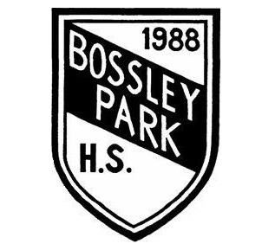
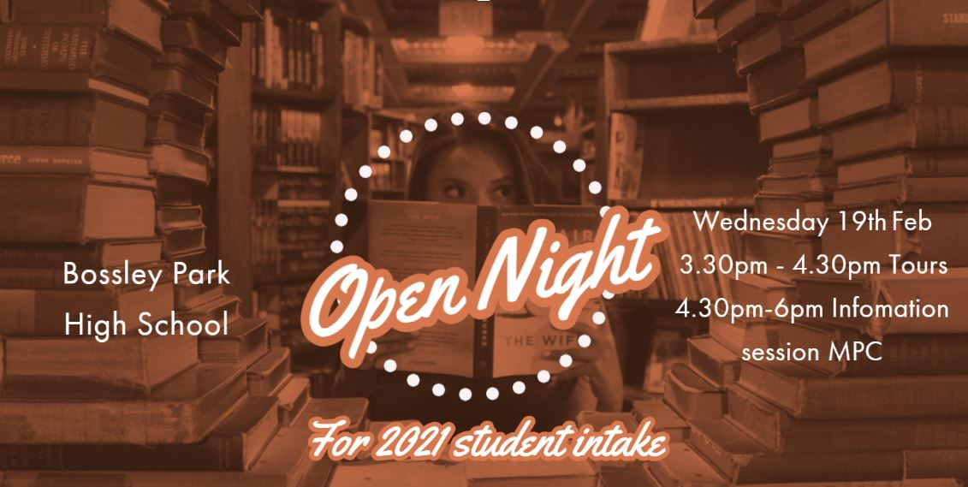
Focussing on
Excellence and Success

“BPHS is committed in delivering quality teaching and learning experiences for all students. The teaching staff are dedicated in supporting all students in achieving to the best of their ability.”
Our school will be holding our annual Open Night on Wednesday 19th February from 4.30pm-6.00pm in the School Hall. We will be having tours of the school from 3.30pm – 4.30pm. Come along, meet the teachers and see how Bossley Park High School inspires students to achieve success, both at school and beyond, through the many opportunities we have to offer.
Gifted and Talented Applications are now available.
See the criteria for application in the booklet or on the school website.

36-44 Prairie Vale Rd, Bossley Park, 2176
Ph: (02) 9823 1033 Fax: (02) 9823 7835
Web Address: http://www.bossleypkh.schools.nsw.edu.au/
Email Address: bossleyph-h.school@det.nsw.edu.au
Socials: https://www.facebook.com/BPHS

